- Unzip the .rar file, you will get 2 file folders. One is named xampp, when the other is named windowscygwin32.
- Copy these 2 file folders to the root directory of C partition, as below image shown.
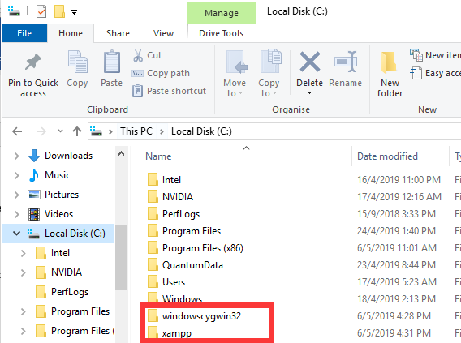
- Open directory “windowscygwin32”, and double click “First To Click.reg” to update system registry.
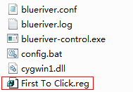
- Reboot the PC. After the PC rebooted successfully, please allow the related .exe file run automatically and allow firewall access.
- Open your browser such as Chrome and input 127.0.0.1 to access its web service on the same pc. If you need to access the web service from other pc, please use the firmware installed PC’s IP address to access.

